MAINCRAFTS TECHNOLOGY
VIRTUAL INTERNSHIP PROGRAM

TASK 1 :
INTRODUCTION TO EMBEDDED SYSTEMS & IoT DEVICE DESIGN

Project Title :
Smart Temperature Monitoring & Alert System Using Arduino UNO

Submitted By: Swapnil Rawade

Branch: Electronics and Telecommunication Engineering (ENTC)

College: RMD Sinhgad College of Engineering, Pune
Internship: Virtual Internship - Embedded Systems & IoT
Academic Year: 2026–27

1. Introduction to Embedded Systems

Definition :
An embedded system is a combination of hardware and software designed to perform a specific function or a set of dedicated functions. It generally consists of a microcontroller or microprocessor along with memory, input/output interfaces, sensors and other electronic components.

2. Applications of Embedded Systems

Area | Examples
Home Automation | Smart lights, smart fans, security systems
Automotive | Airbag systems, engine control, parking sensors
Healthcare | Patient monitoring equipment
Consumer Electronics | Washing machines, microwave ovens, smart TVs
Industrial Automation | Motor controllers, monitoring systems
Robotics | Robot control and navigation
Agriculture | Soil and environmental monitoring
IoT | Smart sensors and connected devices
Aerospace | Flight-control and monitoring systems

Embedded systems are used in many areas of everyday life and industry because they can continuously monitor inputs, process information and control outputs for specific applications.

3. Microcontroller vs Microprocessor

3.1 Microcontroller
A microcontroller is an integrated circuit that contains a processor, memory and input/output peripherals on a single chip. It is commonly used for dedicated control and embedded applications.
Examples: Arduino UNO, ESP32, and Raspberry Pi Pico.

3.2 Microprocessor
A microprocessor is primarily a central processing unit implemented on a chip. It generally relies on external memory and peripherals and is commonly used in general-purpose computing systems.
Examples: Intel Core processors.

3.3 Comparison
Feature | Microcontroller | Microprocessor
Main purpose | Dedicated control applications | General-purpose computing
Memory | Usually integrated | Usually external
Peripherals | Often integrated | Generally external
Power consumption | Generally lower | Generally higher
System complexity | Lower | Higher
Typical applications | Embedded systems | Computers and high-performance systems

4. Microcontroller Platforms

4.1 Arduino
Arduino is an open-source electronics platform based on microcontroller boards and an easy-to-use programming environment. It is widely used for electronics prototyping, education, automation and embedded-system development.
Common applications include sensor monitoring, robotics, automation, prototyping and educational projects. For our project, we will use an Arduino UNO.

4.2 ESP32
ESP32 is a microcontroller platform that provides built-in Wi-Fi and Bluetooth connectivity along with processing and peripheral capabilities. It is widely used in IoT applications where wireless communication is required.
Common applications include IoT devices, wireless sensors, home automation, remote monitoring and smart devices.

4.3 Raspberry Pi Pico
Raspberry Pi Pico is a compact microcontroller development board based on the RP2040 microcontroller. It is designed for embedded applications, sensor interfacing, automation and electronics projects.
Common applications include embedded systems, sensor projects, robotics, automation and hardware control.

5. Comparison of Microcontroller Boards
Feature | Arduino UNO | ESP32 | Raspberry Pi Pico
Microcontroller | ATmega328P | ESP32 | RP2040
Wi-Fi | No | Yes | No
Bluetooth | No | Yes | No
USB | Yes | Yes | Yes
Typical use | Basic embedded projects | IoT/wireless projects | Embedded/control projects
Programming | Arduino IDE, etc. | Arduino IDE, MicroPython, etc. | C/C++, MicroPython, etc.

6. Basic Sensors

6.1 Temperature Sensor
A temperature sensor measures the temperature of its surrounding environment and converts the measured temperature into an electrical signal that can be processed by a controller.
Example: LM35, TMP36.
Applications include temperature monitoring, HVAC systems, industrial monitoring, electronic equipment protection and environmental monitoring.

6.2 Motion Sensor
A motion sensor detects movement or changes in its surrounding environment. A PIR (Passive Infrared) sensor is commonly used to detect the movement of people or animals by sensing changes in infrared radiation.
Applications include security systems, automatic lighting, intruder detection and smart-home systems.

6.3 Light Sensor
A light sensor detects the intensity of light in its surroundings.
Applications include automatic street lights, display brightness control, smart lighting and light detection systems.

7. Mini Project - Smart Temperature Monitoring & Alert System

Problem Statement
Temperature needs to be monitored in many environments such as electronic equipment, storage areas, laboratories and homes. Manually checking temperature is inconvenient and may not provide an immediate warning when the temperature becomes too high.
This project aims to develop a simple embedded system that continuously monitors temperature and provides an alert when the temperature reaches a predefined limit.

Objectives
- Measure surrounding temperature using an TMP36 temperature sensor.
- Process the sensor signal using an Arduino UNO.
- Display the measured temperature through the Serial Monitor.
- Compare the measured temperature with a predefined threshold.
- Activate an LED and buzzer when the threshold is reached.
- Demonstrate basic sensor interfacing and embedded-system programming.

Components Required
Component | Quantity
Arduino UNO | 1
TMP36 Temperature Sensor | 1
LED | 1
Buzzer | 1
220 Ω Resistor | 1
Breadboard | 1
Jumper Wires | As required

System Behavior
The initial alert threshold for the project is set to 35°C. The Arduino continuously reads the TMP36 sensor and compares the measured temperature with this threshold.
Temperature | LED | Buzzer | Status
Below 35°C | OFF | OFF | Normal
35°C or above | ON | ON | Alert

Working Principle
The TMP36 senses the surrounding temperature and produces an analog voltage proportional to the temperature. This analog signal is connected to an analog input of the Arduino UNO. The Arduino reads the sensor voltage, calculates the corresponding temperature and compares it with the predefined threshold of 35°C. When the temperature is below the threshold, the system remains in the normal state with the LED and buzzer switched off. When the temperature reaches or exceeds 35°C, the Arduino switches on the LED and buzzer to indicate an alert.

Reason for Selecting Arduino UNO and TMP36
Arduino UNO is selected because it is simple to program, widely used for embedded-system education and prototyping, and provides suitable analog input and digital output pins for this project. The TMP36 is selected because it provides an analog output proportional to temperature and is straightforward to interface with the Arduino.

Expected Outcome
The completed system should continuously monitor the surrounding temperature. At temperatures below 35°C, the system should indicate a normal condition. At 35°C or above, the LED and buzzer should activate to provide a local temperature alert.

THE SMART TEMPERATURE MONITORING AND ALERT SYSTEM WAS TESTED USING TINKERCAD SIMULATION:
1. CIRCUIT DIAGRAM:
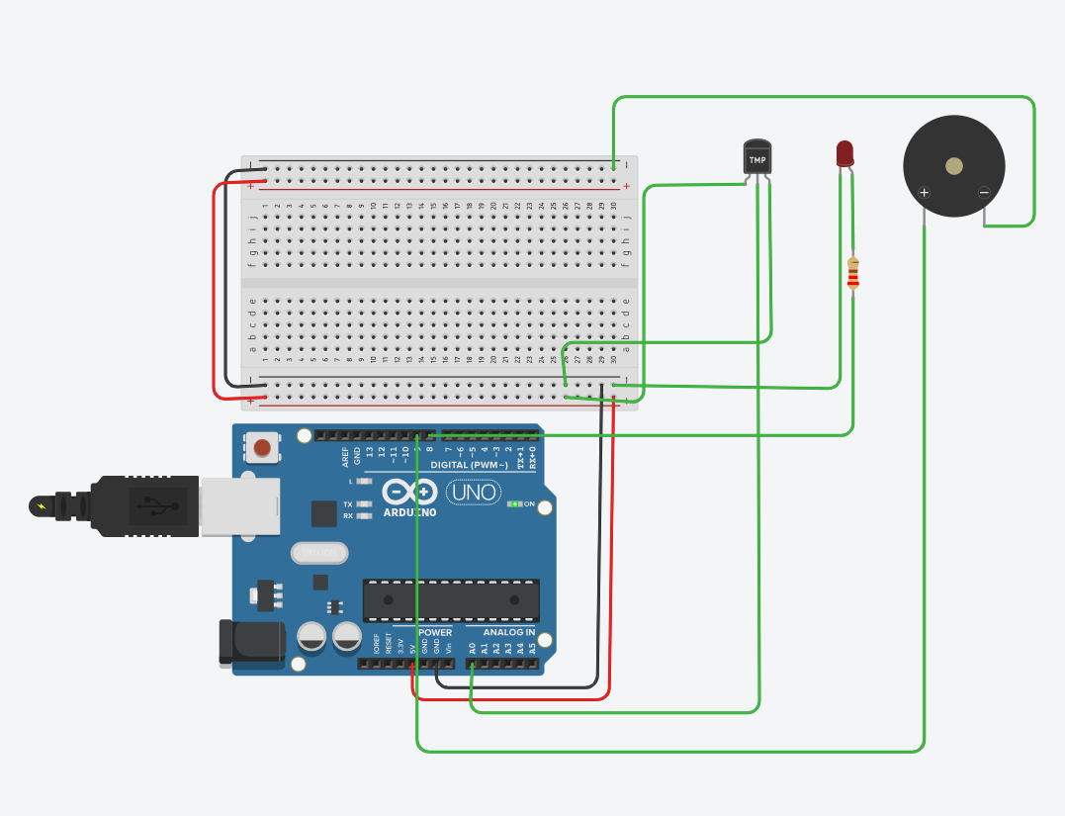

2. NORMAL TEMPERATURE CONDITION:
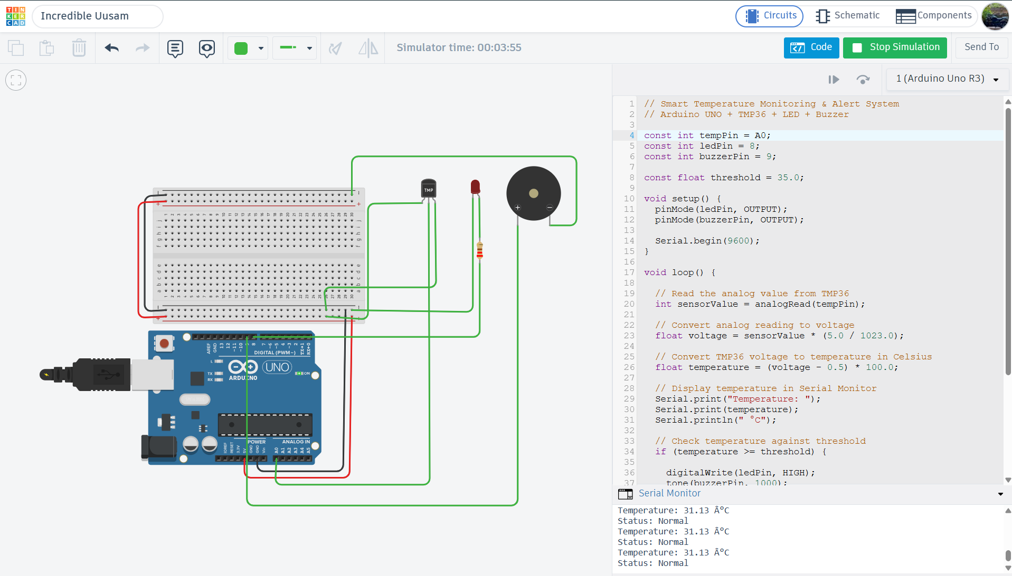

3. HIGH TEMPERATURE CONDITION:
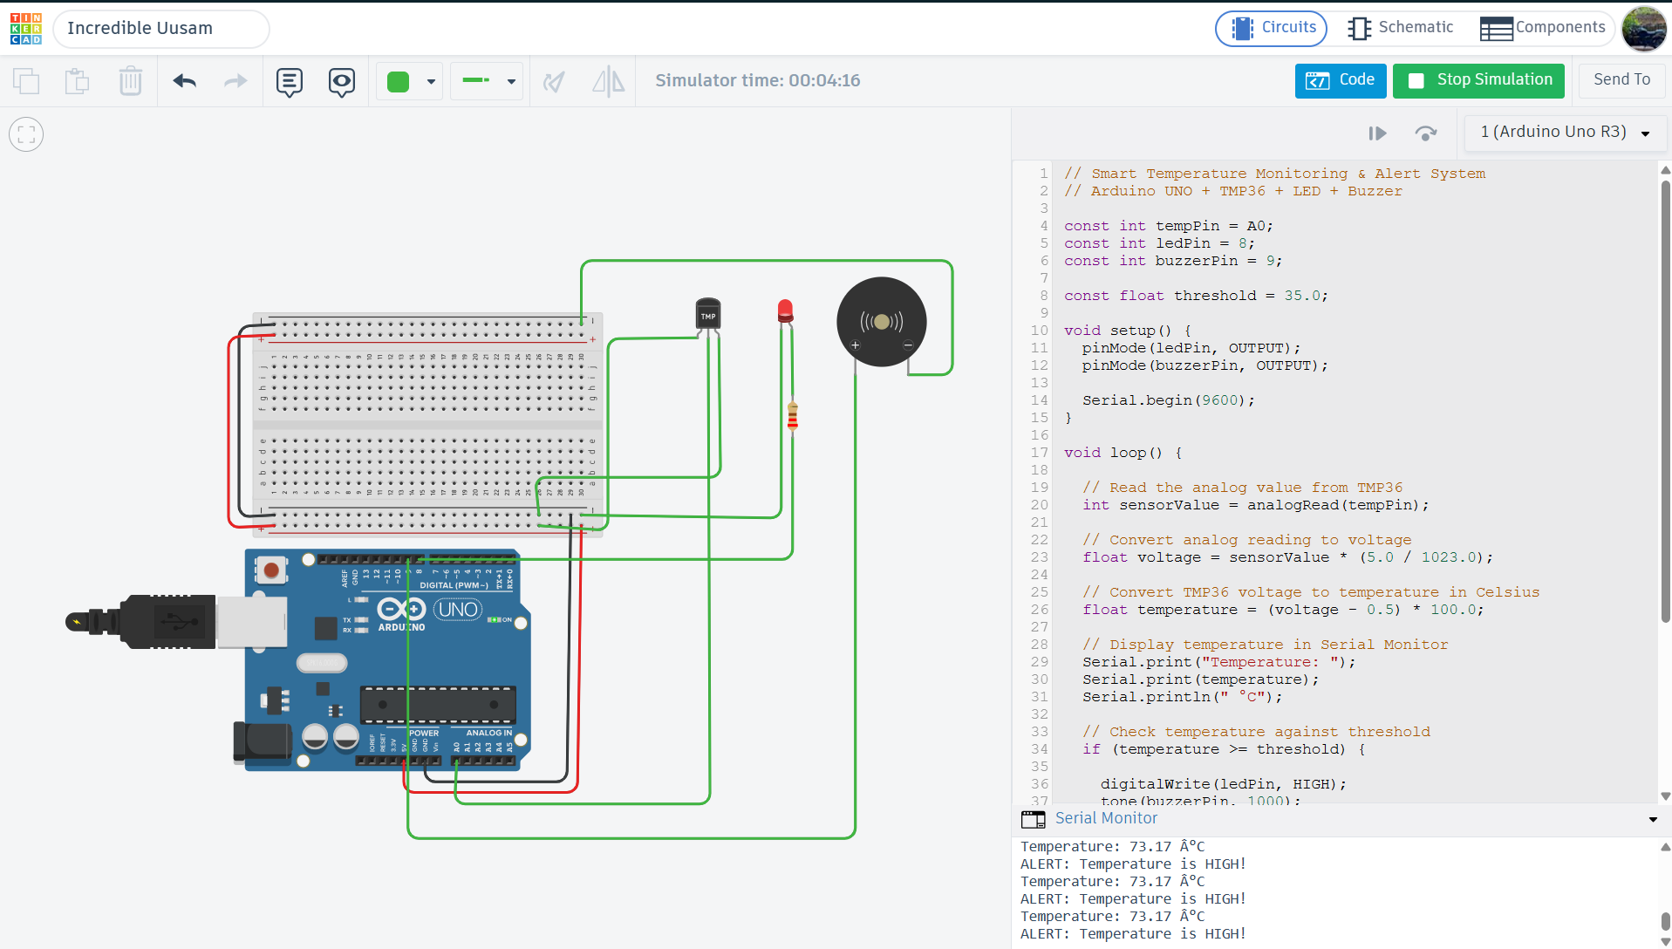
RESULT:
The simulation successfully demonstrated the required temperature monitoring functionality. At 31.13 degree C, the system remained in the normal state. When the temperature was increased to 73.17 degree C, the system detected that the temperature exceeded the 35 degree C threshold and activated both the LED and the buzzer. This confirms the correct operation of the temperature based alert system.

OBSERVATION:
The test demonstrates the basic operation of an embedded monitoring system in which a sensor provides input, and output devices respond according to programmed conditions.

Real-World Applications:
- Server Rooms - Monitors temperature to prevent overheating of servers.
- Industrial Equipment - Detects excessive heating in machines and electronic equipment.
- Cold Storage - Monitors temperature in food and other temperature-sensitive storage areas.
- Greenhouses - Helps maintain suitable temperature conditions for plants.
- Battery Systems - Monitors battery temperature to detect overheating.
- Smart Homes - Can be used to automatically control fans or cooling systems.
- Laboratories - Monitors temperature in equipment and storage areas.

SOURCE CODE:
// Smart Temperature Monitoring & Alert System
// Arduino UNO + TMP36 + LED + Buzzer
const int tempPin = A0;
const int ledPin = 8;
const int buzzerPin = 9;
const float threshold = 35.0;
void setup() {
pinMode(ledPin, OUTPUT);
pinMode(buzzerPin, OUTPUT);
Serial.begin(9600);
}
void loop() {
// Read the analog value from TMP36
int sensorValue = analogRead(tempPin);
// Convert analog reading to voltage
float voltage = sensorValue * (5.0 / 1023.0);
// Convert TMP36 voltage to temperature in Celsius
float temperature = (voltage - 0.5) * 100.0;
// Display temperature in Serial Monitor
Serial.print("Temperature: ");
Serial.print(temperature);
Serial.println(" °C");
// Check temperature against threshold
if (temperature >= threshold) {
digitalWrite(ledPin, HIGH);
tone(buzzerPin, 1000);
Serial.println("ALERT: Temperature is HIGH!");
} else {
digitalWrite(ledPin, LOW);
noTone(buzzerPin);
Serial.println("Status: Normal");
}
delay(1000);
}

Code Explanation
1. Pin Definition: The TMP36 is connected to analog pin A0, the LED to digital pin 8, and the buzzer to digital pin 9. The temperature threshold is set to 35°C.
2. Setup: The LED and buzzer are configured as output devices, and serial communication is started at 9600 baud.
3. Temperature Reading: The Arduino reads the analog signal from the TMP36 and converts it into voltage and then into temperature in Celsius.
4. Temperature Display: The calculated temperature is displayed on the Serial Monitor.
5. Temperature Comparison: The Arduino compares the measured temperature with the 35°C threshold.
6. Alert Condition: If the temperature is 35°C or higher, the LED turns ON and the buzzer sounds. An alert message is also displayed.
7. Normal Condition: If the temperature is below 35°Cthe LED and buzzer remain OFF and the Serial Monitor displays “Status: Normal.”
8. Continuous Monitoring: The Arduino waits for one second and repeats the process continuously.

